ERROR connection with MyJ

1. Select the channel here by choosing the „Choose Target System“:

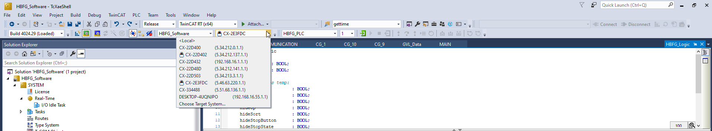

1. Search Ethernet

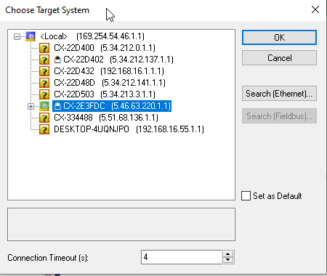

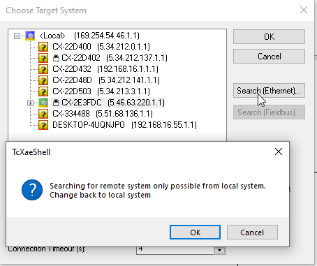

1. Broadcast Search

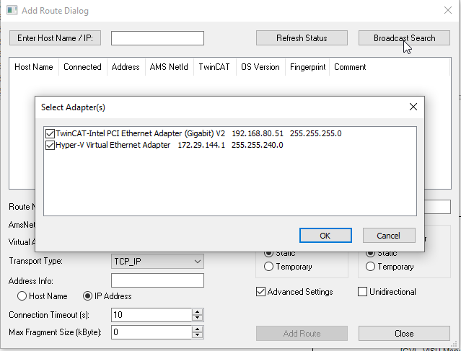

1. Waiting CX-2E3FDC to appear. Then choosing it:

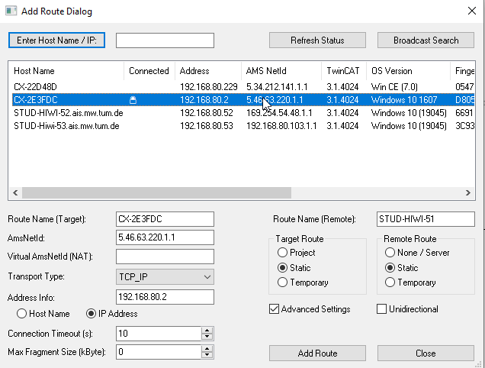

1. Add Route, the passwort is 1: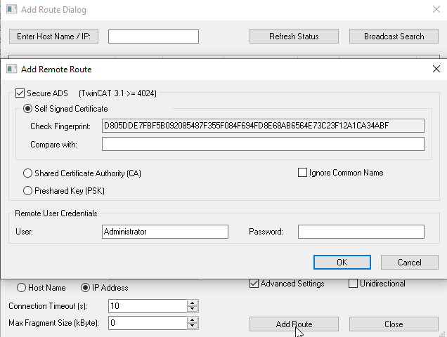
2. Selecting the channel CX-2E3FDC and update the I/O devices.

